Gala Music – 10th KENNER HISPANIC FEST 2020

General Sponsorship

Vendor:
Gala Music, LLC invites you to its 10th Kenner Hispanic Fest 2020 in Kenner, LA, at Kenner Laketown, Saturday, March 28, 3:00 PM to 11:00 PM and Sunday March 29, 1:00pm to 9:00pm
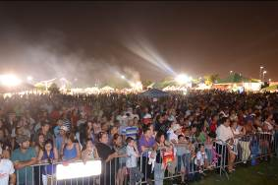
Talent line-up & Activities:
- International Talent TBA
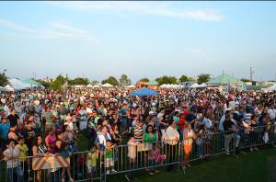
- Local Band’s
- Other local talent
- Vendors
- Craft
- Raffle
- Kids Entertainment
There will be music, dancing, drinks and food, as well as crafts, games (for adults and kids!). Admission $5.00: no coolers, food and drinks.
In order to present an affordable and meaningful experience festival, the following General Sponsor opportunities are available. Your consideration of sponsorship will assist to a successful Hispanic event and a win, win for all.

- GALA SPONSORSHIP LEVEL: This level is +$1,000
For your sponsorship, you and/or organization will receive:
- Advertisement and acknowledgment on print and radio media. (one week prior to event)
- 5 backstage VIP passes with performers
- 10 x 10 space, pop-up tent, 1 table and 2 chairs
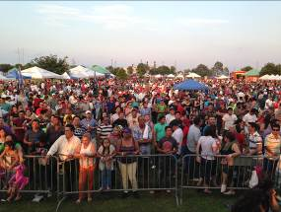

- CLASSIC SPONSORSHIP LEVEL: This level is +$800
For your sponsorship, you and/or organization will receive:
- Advertisement on posters/flyers and acknowledgment.
- 3 backstage VIP passes with performers
- 10 x 10 space, pop-up tent, 1 table and 2 chairs.

- CMC SPONSORSHIP LEVEL: This level is +$500
For your sponsorship, you and/or organization will receive:
- Advertisement acknowledgment.
- 2 backstage VIP passes with performers
- 10 x 10 space (you provide your own 10 x 10 pop-up-tent, table and chairs)

- DBA or Non-Profit SPONSORSHIP LEVEL: DBA $300. For your sponsorship, you and/or organization will receive:
- Acknowledgment.
- 10 x 10 Space only

Kenner Hispanic Summer Fest 2020
Sponsorship Confirmation

Sub-renting of space is prohibited and voids this agreement without refund.
Company
Name

Company
Address

Contact  Name |  | Phone

Company  Website |  | Email

GENERAL SPONSORSHIP LEVEL  ____ Gala or Banner $1,000  ____ Classic or Banner $800  ____ CMC or Banner $500  ____ DBA/Non-Profit $300 | METHOD OF PAYMENT  ____ Check Enclosed  Please make payable to:  Gala Music  ____ Invoice Me

Representative  Signature |  | Date | ____/____/_____

Please email a short paragraph describing you or your company or mission statement and a high resolution logo in JPG or EPS format to galamusicllc@aol.com for the Kenner Hispanic Fest promotional sponsor page/flyer, social media and other collateral printed materials

Gala Music, LLC
Tulio Murillo – Managing Member
4207 Williams Blvd.
Kenner, Louisiana 70065
850-766-4602
galamusicllc@aol.com


