Gala Music – 10th KENNER HISPANIC FEST 2020

Presenter Gala or Classic Platinum Sponsorship

Vendor:
Gala Music, LLC invites you to its 10th Kenner Hispanic Fest 2020 in Kenner, LA, at Kenner Laketown, Saturday, March 28, 3:00 PM to 11:00 PM and Sunday March 29, 1:00pm to 9:00pm
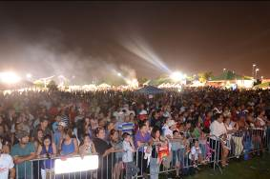
Talent line-up & Activities:
- International Talent TBA
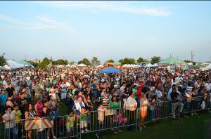
- Local Band’s
- Other local talent
- Vendors
- Craft
- Raffle
- Kids Entertainment
There will be music, dancing, drinks and food, as well as crafts, games (for adults and kids!). Admission: no coolers, food and drinks. Open to the public.
To present an affordable and meaningful experience festival, the following Presenter Sponsor opportunities are available. Your consideration of sponsorship will aid to a successful Hispanic event today and a win, win for all.

- PRESENTER GALA SPONSORSHIP LEVEL: +$5,000
For your sponsorship, you and/or organization will receive:
- Premier Title Sponsor advertising in Hispanic Newspapers Feb & March issue
- Premier Title Sponsor advertising in Hispanic Radio Stations (10 daily spots 1wk prior to event day, KGLA 1540AM/105.7FM and LaCalle 97.9FM
- Premier Title Sponsor TV Ad Telemundo42, 1wk prior to event
- Premier Title Sponsor main area of poster
- Premier Title Sponsor upper stage area
- Premier Title Sponsor VIP reception area
- Premier Title Sponsor 20 backstage passes VIP with performers
- Premier Title 10 x 10 space plus pop-up tent with 2 tables and 4 chairs (if greater space than 10 x 10 is needed, we can accommodate).
- Premier Title Sponsor acknowledgment at the event by MC prior and after each performance and/or presentation
- ATM approval. If not interested, please advise.

- PLATINUM SPONSORSHIP LEVEL: +$2,500
For your sponsorship, you and/or organization will receive:
- Advertisement and acknowledgment on all marketing event, print media, radio and TV. Acknowledgment at the event by MC.
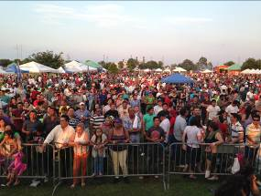
- 10 backstage passes VIP with performers
- 10 x 10 space plus pop-up tent, 1 table and 2 chairs

Kenner Hispanic Summer Fest 2020

Sponsorship Confirmation

Sub-renting of space is prohibited and voids this agreement without refund.
Company
Name

Company
Address

Contact  Name |  | Phone

Company  Website |  | Email

PRESENTER SPONSORSHIP LEVEL  ____ Presenter $5,000  ____ Platinum $2,500 | METHOD OF PAYMENT  ____ Check Enclosed  Please make payable to:  Gala Music, LLC  ____ Invoice Me

Representative  Signature |  | Date | ____/____/_____

Please email a short paragraph describing you or your company or mission statement and a high resolution logo in JPG or EPS format to galamusicllc@aol.com for the Kenner Hispanic Fest promotional sponsor page/flyer, social media and other collateral printed materials

Gala Music, LLC
Tulio Murillo – Managing Manager
4207 Williams Blvd.
Kenner, Louisiana 70065
850-766-4602
galamusicllc@aol.com

